**SF Edge Protection Systems**

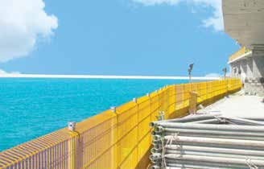

## Mesh guard

Temporary Edge Protection systems are the first line of defence when working at height. SF Mesh guard System utilises steel mesh barriers to protect the open edges on concrete, steel and timber structures. With its industry established connection detail, Mesh guard delivers speedy assembly with economy and safety in mind.

## Shaft gate

SF Shaft gate is an adjustable gate which protects the open edges of Staircase Cores and Lift shafts. This is an important element in fall protection on sites. These open- ings are subject to restrictive access control measures for sub-contractors who need access to the shafts.

## Core guard

SF Core guard is a fixed protection steel mesh which protects the open edges of Staircase Cores and Lift shafts. This is an important element in fall protection on sites.

**SF Mesh Guard Systems**

SF Mesh guard System utilizes steel mesh barriers to protect the open edges on concrete, steel and timber structures. With its industry established connection detail, Mesh guard delivers speedy assembly with economy and safety in mind.

The flexibility and user-friendly features of Mesh guard are fundamental to safe working at height. Components are robust and are painted or galvanized finished for a long life and exposure to extreme weather climates.

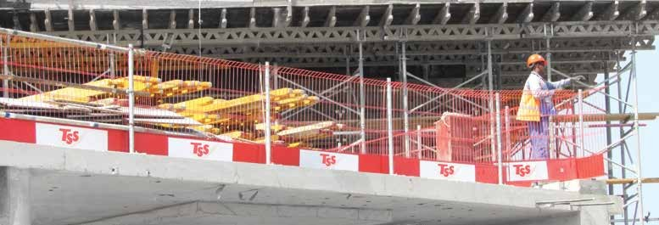The use of Systemized Temporary Edge Protection makes a significant contribution to the reduction of falls on site due to ease of use, increased safety and compliance to EN

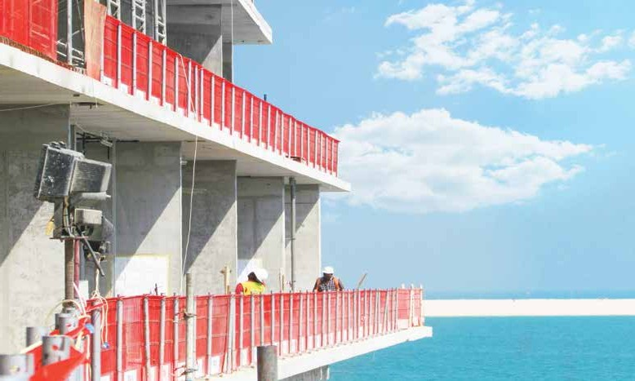

* Provide enhanced protection against fals of objects and workers
* Fully Compliant to EN 13374 Standard
* Cost effective systemised solution
* Built-in welded steel toe board, 260mm high
* Close mesh spacing (60mm vertically) with 1.15m overall height
* Customer’s Logo can be attached on toeboard
* Galvanised wire with powder coat finish to customer’s colour